Title of Your Manuscript (Capitalized Each Word)
First Author¹, Second Author² , Third Author³, and Forth Author⁴
¹Affiliations
²Affiliations
Corresponding author email: firstauthor@gmail.com
Abstract
Provide a concise summary of the chapter (150–250 words), highlighting its main objectives, methodology, key findings, and contributions.
Keywords: List 5–10 relevant keywords separated by commas
Heading 1 Example: Introduction
Introduce the topic, background information, the chapter's objectives, and its significance. Clearly state the research problem and the scope of the discussion.
Subheading for Heading 1
[Details under this subheading.]
Heading 2 (Second Major Section Title)
Example for Figure and Table
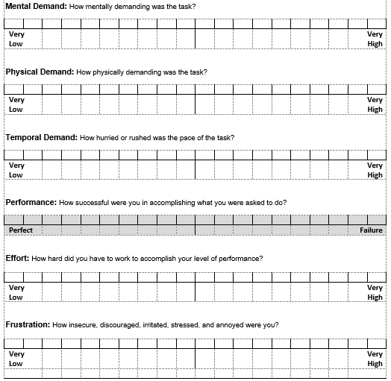
Figure 1. NASA-TLX Questionnaire (Adopted from NASA Ames Research Center [23])

Table 1. NASA-TLX Subscales Definition (Adopted from NASA Ames Research Center (1986))
Indicator | Rating | Description
Mental Demand | Very low, Very high | How much Mental activity is required when learning through digital video courseware
Physical Demand | Very low, Very high | How much Physical activity is required when learning through digital video courseware
Temporal Demand | Very low, Very high | How much Time Pressure fulfilling to learn all modules when learning through digital video courseware
Performance | Perfect, Failure | How big is the Success Level in fulfilling to learn all modules when learning through digital video courseware
Frustration level | Very low, Very high | How much effort did you put in physically and mentally in fulfilling the required tasks while learning through digital video courseware
Effort | Very low, Very high | How much Pressure Do You Feel to Feeling Unsafe, Discontinued, Offended, or Disturbed to fulfil the required tasks while learning through digital video courseware

Conclusion and Recommendations
Summarize the main points of the chapter, including key findings, implications, and future directions for research or practice.
References
Use APA (7th edition) format for all references. Ensure that every in-text citation has a corresponding entry in the reference list.
Example:
Smith, J. (2020). Title of the Book or Article. Publisher Name. DOI or URL.

Acknowledgment
This research was not funded by any grant.
Appendix (Optional)
Include supplementary material, such as datasets, survey questions, or additional figures and tables.
Notes to Authors
- Formatting: Use Times New Roman, 12-point font, double-spaced, with 1-inch margins.
- Figures and Tables: Include descriptive titles. Position them close to the text where referenced and provide source citations if applicable.
- Length: Chapters should be approximately 8,000–10,000 words, unless otherwise specified.
- Plagiarism Check: Ensure the chapter is original and properly cited.

